Hello again. Hope you are all fine. I am sending you the best season ‘s greetings.

Meals and cooking ( worksheet 5)
- Do these online exercises and learn words to talk about meals and ways of cooking food. Match the words and pictures. Click:
https://learnenglish.britishcouncil.org/vocabulary/beginner-to-pre-intermediate/meals-and-cooking
- Do the 5 online quizzes. Click finish to see your score after each one. Do not send me back your answers/scores.
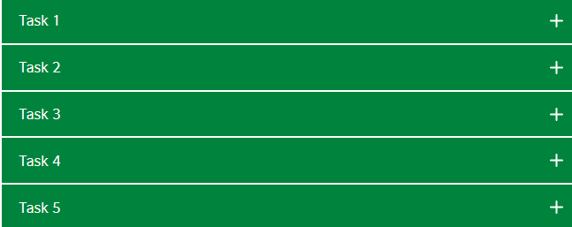
Speaking practice
Food for thought:
How often do you cook? Who do you cook for more, friends or family? What are some of the dishes you most enjoy preparing?

A recipe
- Look at the recipe and do the exercises to improve your writing skills. Click below:

https://learnenglishteens.britishcouncil.org/skills/writing/elementary-a2-writing/recipe

- Do the 3 online quizzes you see below. Click finish to see your score after each one. Do not send me back your answers/scores.

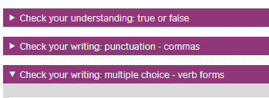

Now I hope you can describe the method and tell somebody how to cook and follow a recipe.
That’s only for speaking practice. But be ready for a recipe anytime I ask you.
Thank you!! Enjoy the quizzes!
Britishcouncil-learnenglishteens

